Assistive Systems:
Technologies that Help People Do, Sense, and Think
Jeffrey M. Bradshaw
BYU-Idaho University Forum Presentation
16 May 2013

Abstract

One of the central research themes of the Florida Institute for Human and Machine Cognition (IHMC) is “assistive systems” — technologies that help people do, sense, and think. From advanced NASA space rovers to robotic assistants, from robotic legs for the disabled to devices that allow the blind to see through their tongue, and from advanced visualization to software agents that help analysts make sense of complex, high-tempo cyber events, Bradshaw will describe how researchers at IHMC increase human performance through out-of-the-box thinking.

Biographical Sketch

Jeffrey M. Bradshaw (Ph.D., Cognitive Science, University of Washington) is a Senior Research Scientist at the Florida Institute for Human and Machine Cognition (IHMC) (www.ihmc.us/groups/jbradshaw; en.wikipedia.org/wiki/Jeffrey_M._Bradshaw). His professional writings have explored a wide range of topics in human and machine intelligence. In addition to his professional activities, he is currently completing a volume of scripture commentary on the stories of Enoch, Noah, and the Tower of Babel (www.templethemes.net). Jeff serves as a counselor in the Pensacola Florida Stake Presidency.

Note: The first part of this presentation, which highlights examples of the kinds of work done at IHMC has not been transcribed. The second part of the presentation, which discussed life lessons about schooling and work is transcribed below.

********

I would like to spend the last portion of our time together to speak about some of the things I learned during my school years — and since.

1. The Lord gets the best and the first. As most of us do in our early years, I once held great ambitions for my professional future. However, one evening, a few months before I left BYU-Provo to continue my studies at the University of Washington, I had the chance to hear a fireside given by Hal Miller, a professor of psychology who had recently finished his doctoral studies at Harvard. As I recall it, he talked about how LDS students with high ambitions may sometimes be faced with difficult choices that will require the sacrifice of professional goals in order to attend to the higher priorities of family and church service. I was naïve, and the thought that I might not be able to accomplish everything I had dreamed of professionally without compromising my covenants was new to me. However, the clear impression came to me that night that in my life I would never accomplish some of the things that I had dreamed of and worked for in my education. I felt no disappointment in that realization, but rather a great peace in knowing that I had other, more important work of an eternal nature to do. I made the determination then to never let my schooling or work stand in the way of my family responsibilities or of calls to serve in the kingdom.

I have been far from perfect in following through on my determination, but I can say truthfully that have felt great joy in those times when I have made the right choice in giving the Lord the best and the first in my life. Our family grew to four children during the most intense years of my graduate study. Our small children were a great source of joy to Kathleen and me, and helped me keep my balance and perspective during this busy time. I was the only married student in my class, and eventually also took on full-time employment, so my situation was very different from that of my peers. In addition, it seemed that every time I found myself poised to take a leap forward on my dissertation research, my church responsibilities would increase. However, in retrospect, I believe that this church service was exactly what I needed in my personal situation to keep my testimony strong and vibrant and growing. Moreover, it later became apparent that had I graduated earlier, the professional opportunities that eventually opened up for me would not have been available. I have learned to appreciate what Elder Neal A. Maxwell once said: “Since faith in the timing of the Lord may be tried, let us learn to say not only, ‘Thy will be done,’ but patiently also, ‘Thy timing be done.’”

One way I try to express to the Lord on a daily basis my determination to give him my best and first is to make prayer to Him the first and last bookends of my day. Elder Marion D. Hanks reported having asked President David O. McKay, “How would you suggest I maintain my spirituality?” President McKay said he did five simple things every day:

I arise early.
I wash my body.
I put on my new linen.
I subdue my spirit before the Father.
I wait for the inspiration of the Father.

Because I know of the great blessing it’s been in my own life, I invite each of you to consider getting up a little earlier in the morning than you do now, to clean yourselves up enough to look presentable before the Lord, and to make communion with Him the first thing you do every day. Likewise, make the Lord the very last thought and object in mind when you go to sleep. If you do so, I promise that your sleep will be untroubled, your dreams will be sweet, and if the Lord chooses to speak with you in the stillness of night, you will be ready to hear Him. I testify with gratitude to God, of the great truth of the Savior’s words: “Wherefore, seek not the things of this world but seek ye first to build up the kingdom of God, and to establish his righteousness; and all these things [everything you need to be happy and to do His will] shall be added unto you.”

2. Study the scriptures with no less intensity and fervor than you bring to your other studies. I owe my awakening to the beauty and depth of scripture to a course taught at BYU by Brother Arthur Henry King. Converted to Mormonism in Britain during his later years, Brother King was a Shakespeare scholar and professional “stylistician” — in other words, an expert in how the subtleties of language reveal to readers, both intentionally and unintentionally, not only the character of the fictional persons in a story but also the character of the authors themselves. Indeed, Brother King mentioned how, when he was first introduced to the missionaries, it was the style of the First Vision account that convinced him that Joseph Smith was telling the truth. In his highly trained eyes, it was an account written by an honest man.

Brother King believed strongly in the virtue of reading the scriptures aloud. He taught the members of our class how to experiment with different approaches to reading the same verse, how to listen to the wisdom of the spoken voice, and how the varying of emphasis and pauses for breath could highlight different shades of meaning in the text. This approach differs from the facile skimming for rapid information ingestion that is the stuff of our daily business.

During my daily work at IHMC, I’m caught up in creating new ideas every day. It’s a dream job, and I wouldn’t want to trade places with anyone I know. However, it’s a challenge in the sense that I can’t stand still. Although it’s true that every innovation builds to a degree on the past, the pace of change is so rapid that I am constantly occupied with throwing away the results of recent efforts to accommodate new and better ones.

For that reason, it is wonderful and satisfying to study the scriptures, where I can have the sense over time of continually building up a deeper understanding of God’s outlook on the human situation. Complementing the insights that come from study is the knowledge that comes from trying to live the Gospel. I know that the scriptures are true because I have lived things that mirror, in their own small way, what I have read in them.

Sometimes living the Gospel can be a lonely thing. There are difficult things that you will be called on to do that no one besides yourself and God will see and understand. In fact, I think I could say that such work, the work that is only truly known and understood by yourself and God — that you are bound to do because of your covenants and that you want to do because of that special, personal love that develops between yourself and your eternal Father — that divine work, hidden even to your closest friends and family, is the most important and authentic work you will end up doing in life. In difficult and solitary moments, I think of a statement in a movie I saw about the life of C. S. Lewis: “We read to know we’re not alone.” To read the words of God in scripture and then, at times, to hear that same voice within my own soul is a supreme joy. Likewise, the spiritual power I sense in the speech and writings of godly men and women eradicates the isolating barriers of time, culture, and distance, and stirs precious feelings of high communion. Because of what I have read, seen, heard, and experienced over a lifetime, I can say truthfully that my faith is more real than real to me. With the Primary children I can sing with conviction, “I know the scriptures are true.”

3. The most important thing about your job is not what you are paid to do, but the relationships you are enabled to develop with those you work with and serve, the example you set, and the Gospel you share. When I was growing up, Elder S. Dilworth Young, a member of the Presidency of the Seventy, lived around the corner from my family. He would sometimes come to ward events and tell stories around the campfire. He really knew how to tell a story! Though I hardly knew him, he knew who I was. He greeted me personally and went out of his way to take an interest in what I was doing. One Sunday afternoon I met Elder Young as he was taking a walk up our street with his wife Hulda. He asked me what I was studying, and when I told him he said, in his characteristically direct and honest manner, “Oh, why do you want to do that? Everybody I know in that profession is miserable.” I said that I wanted to help people. Then he advised me something like this: “The greatest help you can offer people will come through your church service. Choose a profession that will provide for your family and give you the freedom to serve anywhere the Lord calls you. Then, when you retire, you can serve the Lord full-time.”

I’ve learned in life that he was right. I don’t think anything I’ve done or will do professionally has done much lasting good for anyone. But in the course of doing my work, I’ve built wonderful and lasting relationships with admired colleagues and with those I’ve tried to serve, and I treasure those relationships far more than the work itself. The Lord has led me to professional opportunities that have allowed me to provide for my family and to help others in need, and have also given me the schedule flexibility I needed to serve in whatever thing I’ve been called to do. In that church service, I have had my greatest satisfactions. My most joyful anticipation in eternity is seeing all those I love, my family and friends, in God’s presence.

4. Prepare to be surprised. The road of my personal and professional life has taken unexpected twists and turns. Nothing resembling the kind of work I do now existed at the time I started my schooling. Prayer and priesthood blessings have been an essential part of the choices Kathleen and I have made at critical junctures in our life. For example, the decision to change the focus of my graduate studies was confirmed in a blessing from a choice friend, and I received needed reassurance about our first family move to France in a blessing from my father. Major transitions have gone smoothly and minor crises have been averted because of spiritual impressions received in the course of visits to the temple, careful reading of patriarchal blessings, and prayerful discussions with trusted friends and family. If you are unsure of where to go next in your own life, just begin walking in faith a few steps into the darkness, carrying a prayer in your heart. Elder Dallin H. Oaks gave the comforting counsel that: “Revelation comes most often when we are on the move.” President David O. McKay told of how a “spiritual manifestation for which [he] had prayed … came as a natural sequence to the performance of duty.”

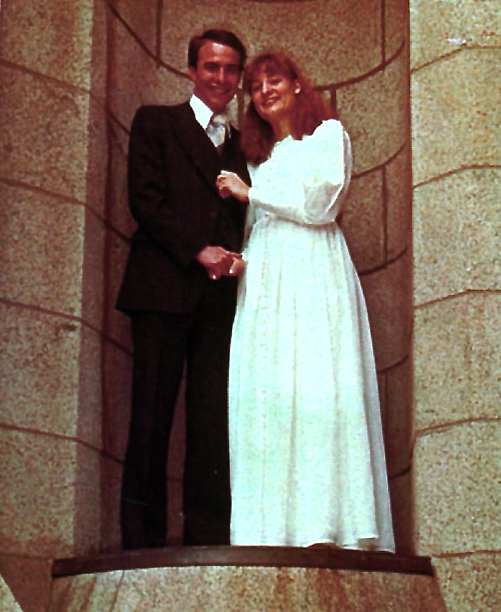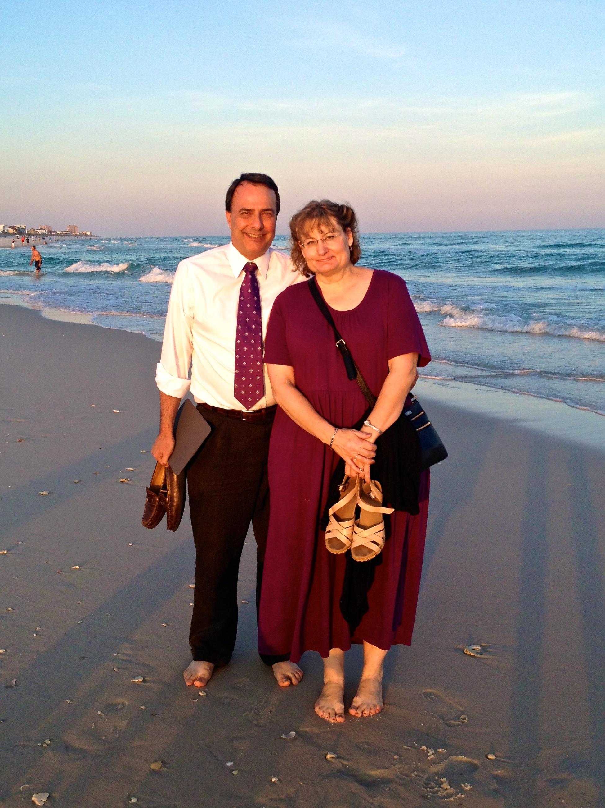

5. Marry well. In that respect, I am blessed more than I deserve. Here you see Kathleen and me at the Salt Lake Temple on our wedding day, April 27, 1979. Here we are a few weeks ago on the night we celebrated our thirty-fourth wedding anniversary. I sometimes tell people that I have one reason — and only one reason — to think that I am smarter than my wife. And that reason is because I was smart enough to choose her, while on the other hand, she was so kind-hearted that she foolishly chose me.
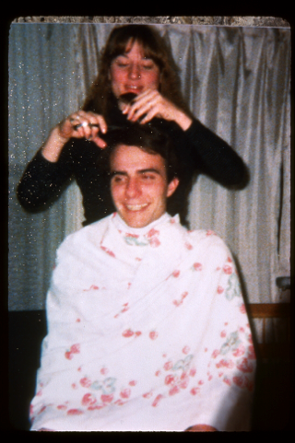
I like this picture of the two of us, taken some months before we were married. Kathleen has been cutting my hair ever since. When we were first married used the money saved on haircuts for our date nights. At her request, I tried to cut her hair once, but lost my courage after the first few snips.

We were — and are — different in so many ways. I grew up in a large family of sometimes very noisy siblings, she grew up in a quiet home with one brother. I love camping, she got more than her fill of camping as a small child when her father would park their travel trailer for days in the middle of a hot, barren desert. I love classical music, and she usually prefers something else. She is skilled in creating beauty with her hands, while I can only stand back in awe and watch. She excels in details, while I struggle to keep the big picture in view. When she drives, she takes the most direct route, while I usually follow the freeway. When I am thinking “turn right,” she says, “turn left.” She is reliably punctual, I was born fifteen minutes late — and I’ve been trying to catch up ever since.

If you were to ask her about the one thing we have in common, the thing that attracted us to each other as marriage partners, the way she will tell it to you is that we were both “serious.” In saying that, she doesn’t mean that neither of us have a sense of humor — though at times she has questioned the shape that mine takes. What I think she means is that we are so constituted that we take one thing in life more seriously than anything else: following our Savior. Jesus, in fact, taught that if we were serious about our duty to God, we could not really be serious about anything else — you cannot serve God and Mammon. In the end, nothing else besides this choice to put God first in our lives matters. From that strategic choice, all the small tactical choices in life flow naturally. They are already determined.

Let me say here, that there is a difference between young love and mature love. Young love is thrilling and exciting, sweet and precious, and the best thing that can happen to a man and a woman in their early lives. However, I can testify from my own experience over the years that there is nothing in young love that compares with the more beautiful, rich, and mature love of a lifetime spent together. We were all witnesses to the sweet moment when, soon after Sister Hinckley’s death, President Hinckley confided his poignant feelings to us at General Conference:

Before I married her, she had been the girl of my dreams .… And now in my old age, she has again become the girl of my dreams.

Conclusions

My wish for each of you is for happy and productive lives — blessings that will come to you in the course of doing your duty. Though I don’t want to minimize the many serious problems in the world that seem to be aggravating daily, what I have experienced of the goodness of God over a lifetime has, to my own surprise, given me a feeling of increasing optimism. The Gospel is the source of my strength, my joy, and my hope for a better life here and hereafter. May God bless each of you …

References

Children's Songbook of The Church of Jesus Christ of Latter-day Saints. Salt Lake City, UT: The Church of Jesus Christ of Latter-day Saints, 2005.
Hinckley, Gordon B. "The women in our lives." Ensign 34, no. 11 (November 2004): 82-85.
Kikuchi, Yoshihiko. 2011. How do you open your heart to heaven? (BYU Devotional given 18 January 2011). In BYU Speeches. http://speeches.byu.edu/?act=viewitem&id=1936. (accessed May 12, 2013).
King, Arthur Henry. "Afterword." In Feasting Upon the Word, edited by Dennis Packard and Sandra Packard, 229-37. Salt Lake City, UT: Deseret Book, 1981.
———. 1971. "An Account of My Conversion." In Arm the Children: Faith's Response to a Violent World, edited by Daryl Hague, 27-53. Provo, UT: BYU Studies, 1998.
———. 1971. "The Child is Father to the Man." In Arm the Children: Faith's Response to a Violent World, edited by Daryl Hague, 101-19. Provo, UT: BYU Studies, 1998.
———. 1971. "Rhetoric." In Arm the Children: Faith's Response to a Violent World, edited by Daryl Hague, 199-215. Provo, UT: BYU Studies, 1998.
———. 1992. "Education in the home." In Arm the Children: Faith's Response to a Violent World, edited by Daryl Hague, 229-48. Provo, UT: BYU Studies, 1998.
———. 1992. "Joseph Smith as a Writer." In Arm the Children: Faith's Response to a Violent World, edited by Daryl Hague, 285-93. Provo, UT: BYU Studies, 1998.
Maxwell, Neal A. "Plow in hope." Ensign 31, May 2001, 59-61.
McKay, David O. Cherished Experiences from the Writings of David O. McKay. Salt Lake City, UT: Deseret Book, 1955.
Oaks, Dallin H. "Sharing the Gospel." Ensign 31, November 2001, 7-9.
———. "Timing." In Brigham Young University 2001-2002 Speeches, 187-93. Provo, UT: Brigham Young University, 2002. http://speeches.byu.edu/reader/reader.php?id=684. (accessed February 16, 2010).
Packard, Dennis, and Sandra Packard. Feasting Upon the Word. Salt Lake City, UT: Deseret Book, 1981.

Endnotes

N. A. Maxwell, Plow, p. 59. See also D. H. Oaks, Timing.
Cited in Y. Kikuchi, How do you open your heart to heaven? (BYU Devotional given 18 January 2011).
JST Matthew 6:33.
A. H. King, Account, pp. 42-43, 45; A. H. King, Joseph.
A. H. King, Afterword, pp. 233-236; A. H. King, Child, pp. 101-102; A. H. King, Rhetoric, pp. 201-204; A. H. King, Education, pp. 240-242; cf. D. Packard et al., Feasting, pp. 18-20, 199-203, 209-213.
http://www.script-o-rama.com/movie_scripts/s/shadowlands-script-transcript-winger-hopkins.html
Children's Songbook, Search, Ponder, and Pray, p. 109.
D. H. Oaks, Sharing, p. 9.
D. O. McKay, Cherished, p. 16.
G. B. Hinckley, Women, p. 82.

